MACHINE PROBLEM

PYTHON SOLUTION PROBLEM # 2

Aguinaldo, Kurt 2ECE – A

Sales, Ace Lawrence

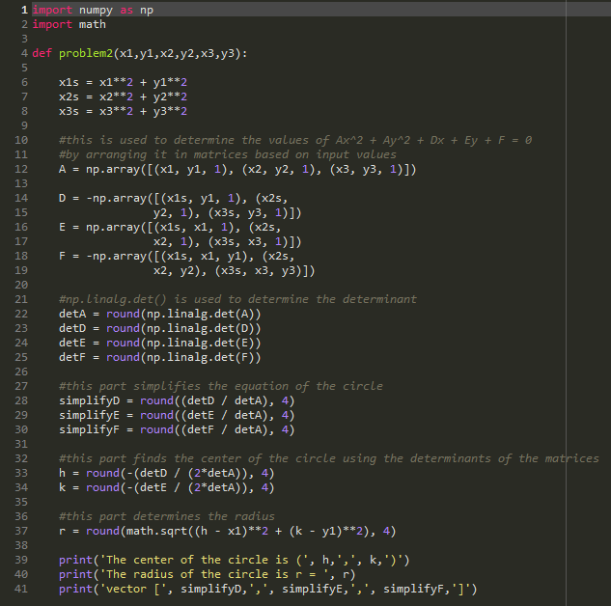**SCRIPT FILE:**

Using input problem2(3,4,5,6,7,9)

**OUTPUT:**

